**Assignment:3**

* **Problem Statement:** Create IAM user and give full access to S3
* **Steps:**

1. Log into AWS and click on IAM user it.

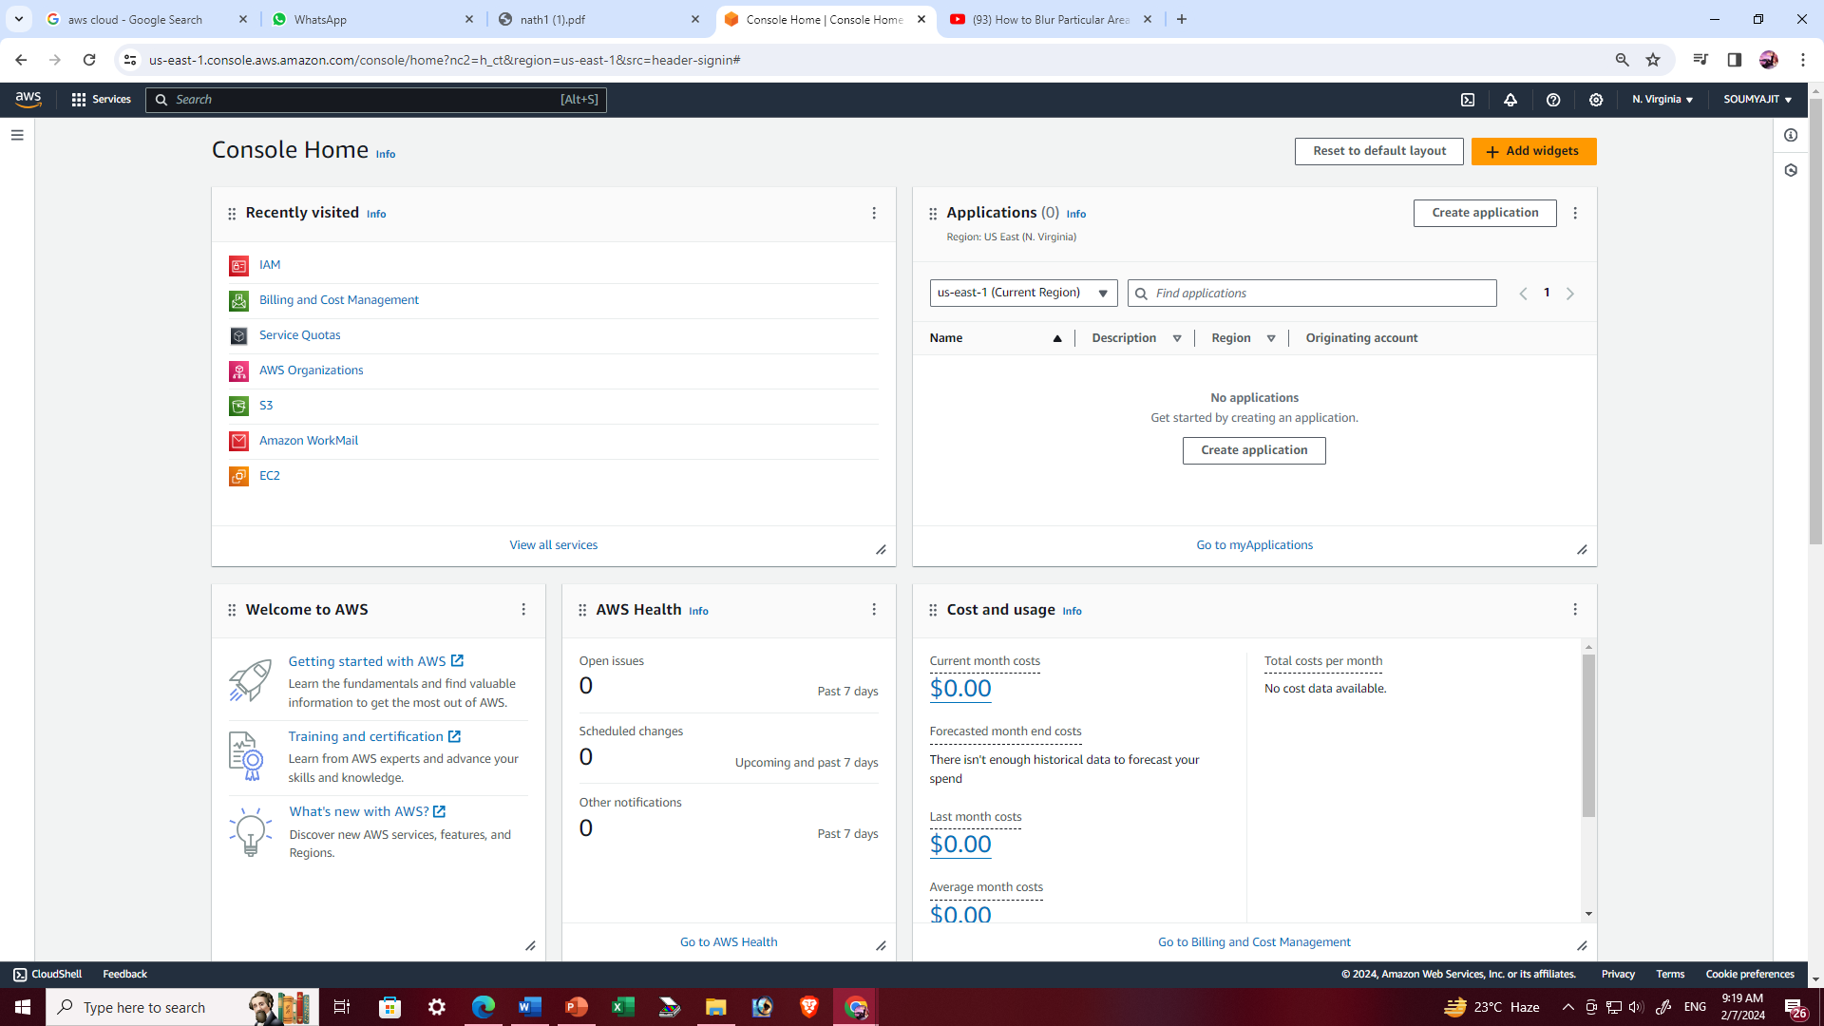

1. Click on ‘Users’.

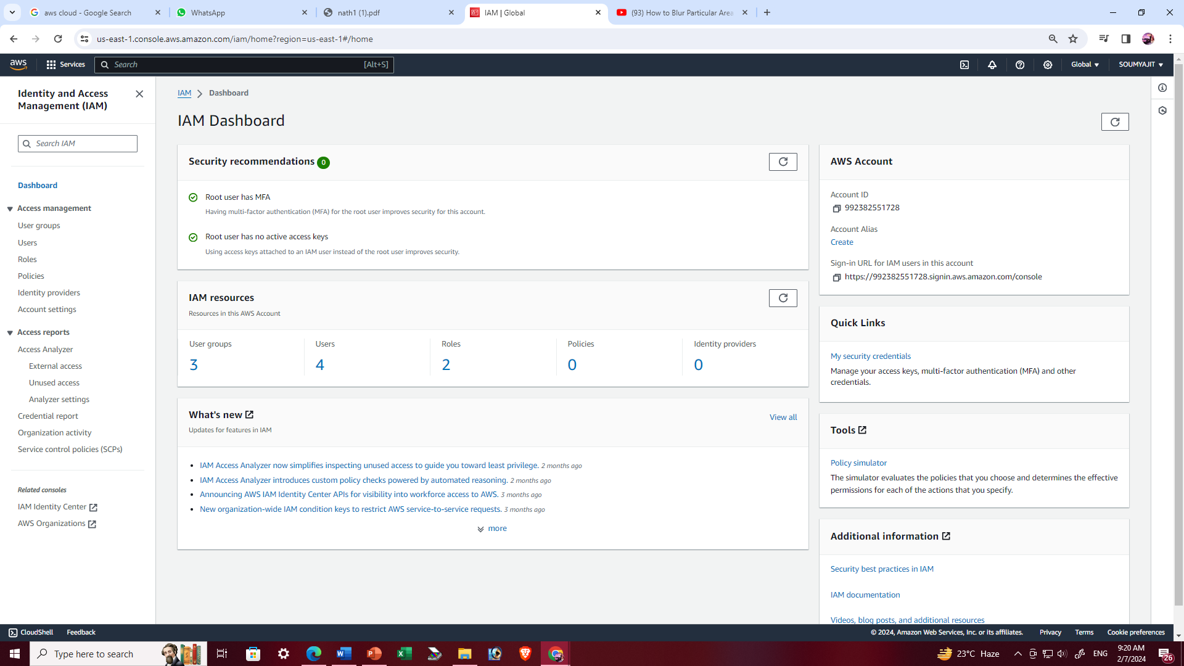

1. Click on ‘Create User’.

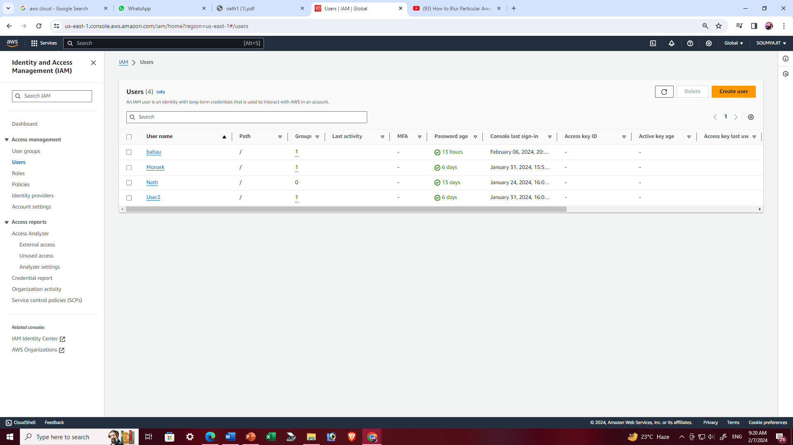

1. Provide ‘User details’, tick off the check box and click ‘I want to create an IAM user’ follow the snapshot step given below and then ‘Next’.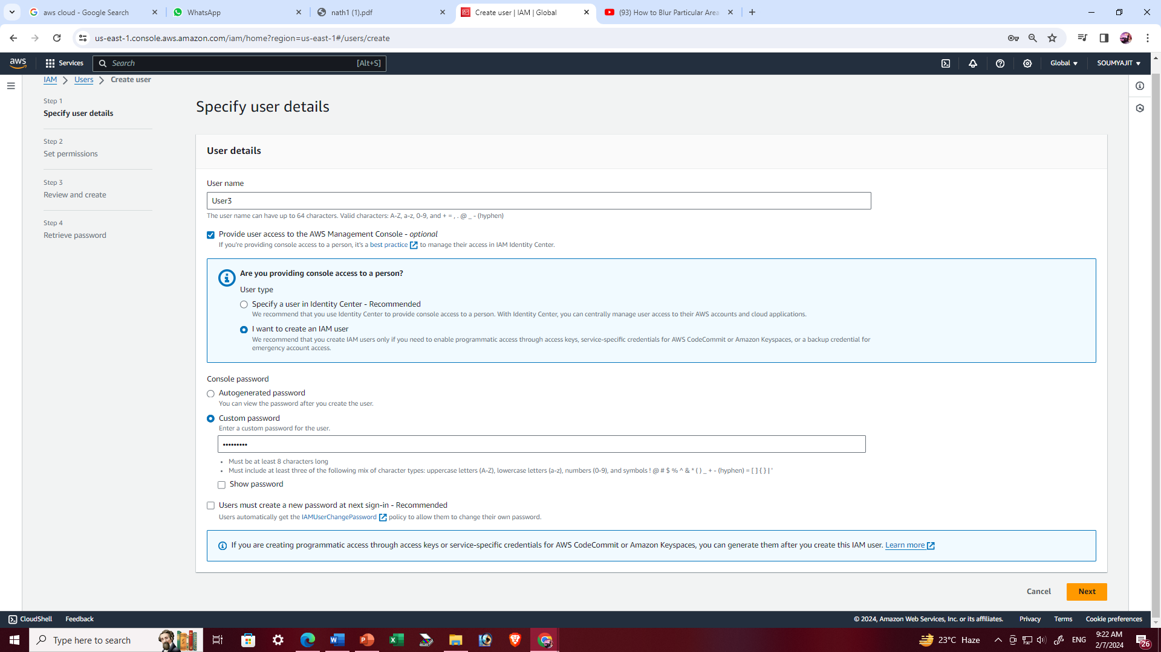
2. Click on ‘Add user to group’ and go to ‘Create group’ and ’Next’.

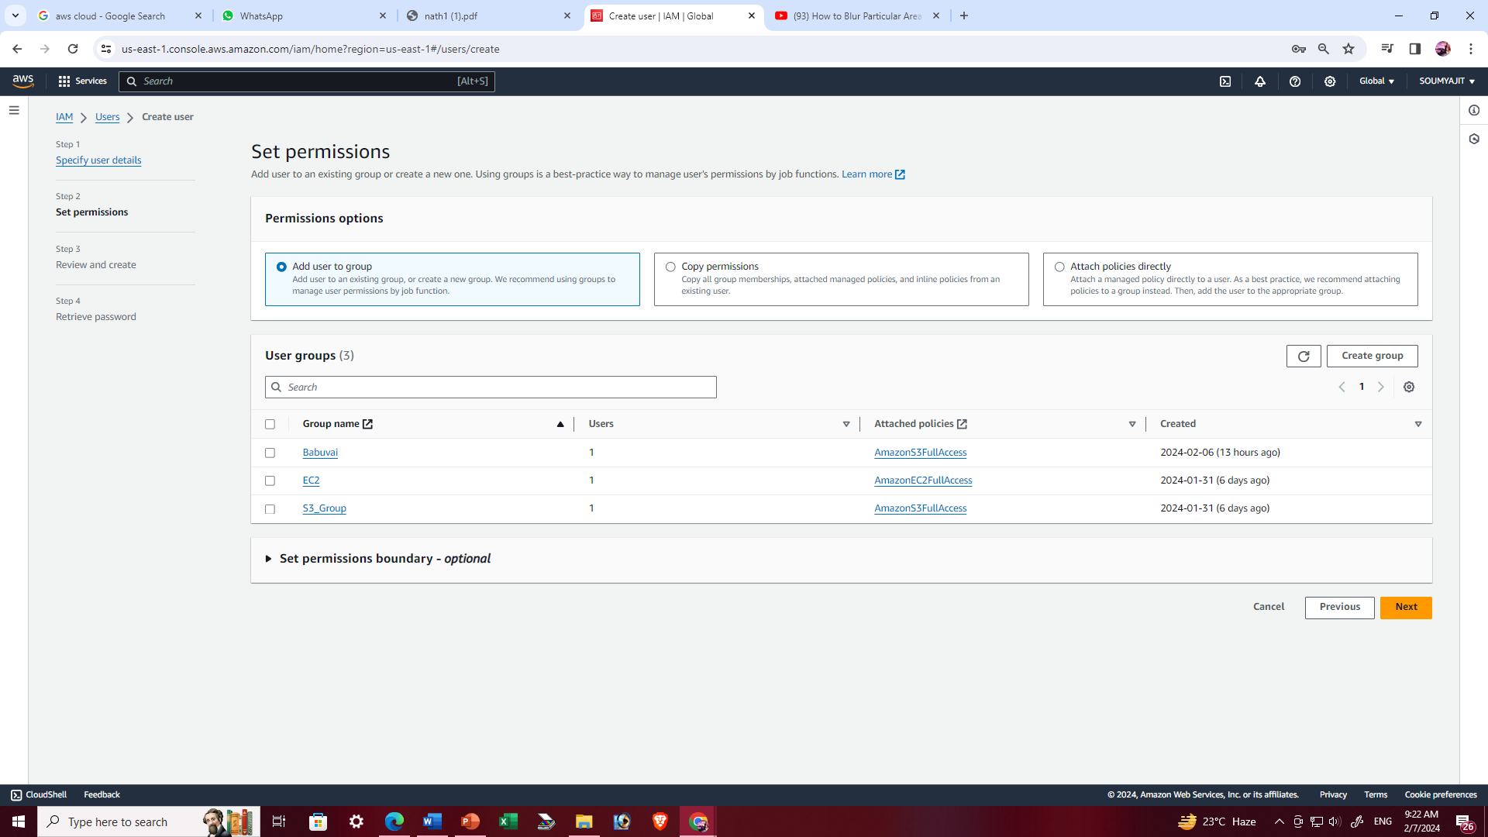

1. To ‘Create user group’, first provide ‘User group name’, then from permission policies search for s3 and choose ‘full access of s3’ for that group.

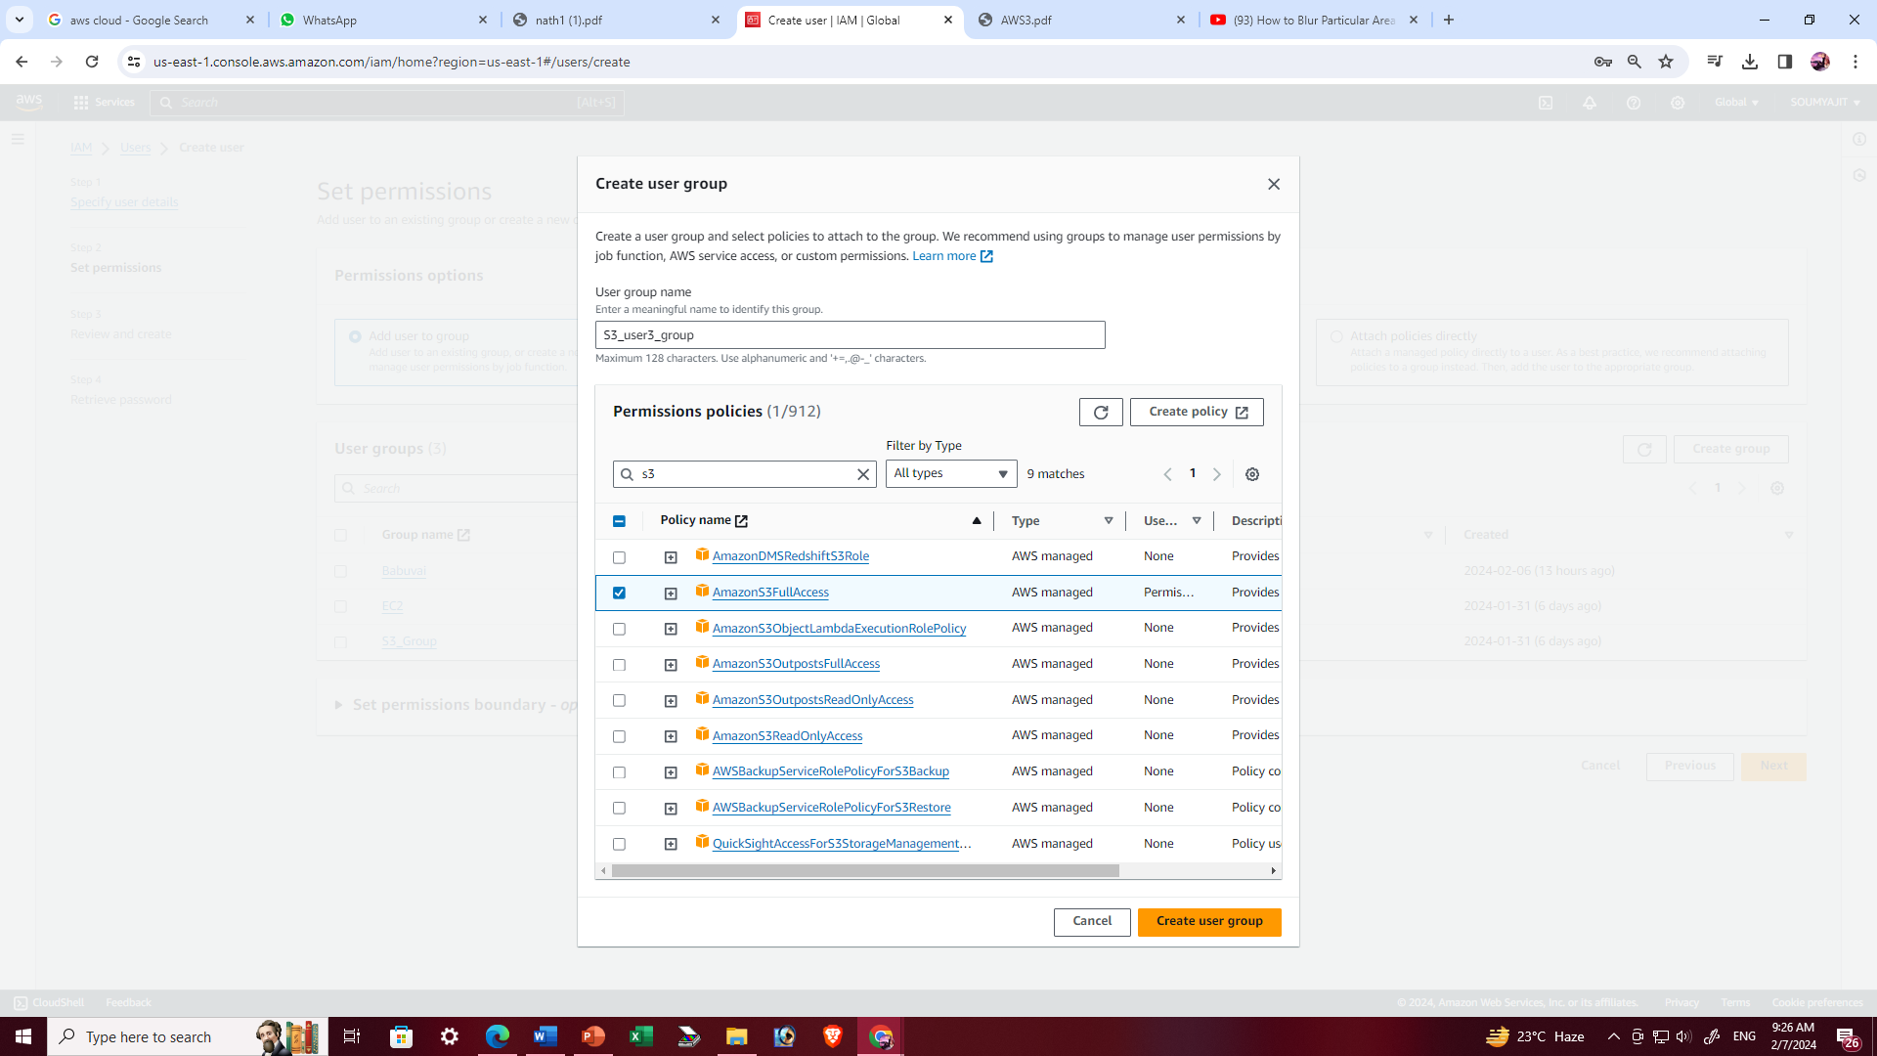

1. ‘S3_user3_group’ is successfully created, then tick off the checkbox of ‘S3_user3_group’ in ‘User groups’, so that our IAM user is connected to this group and gets the required permission then click on ‘Next’.

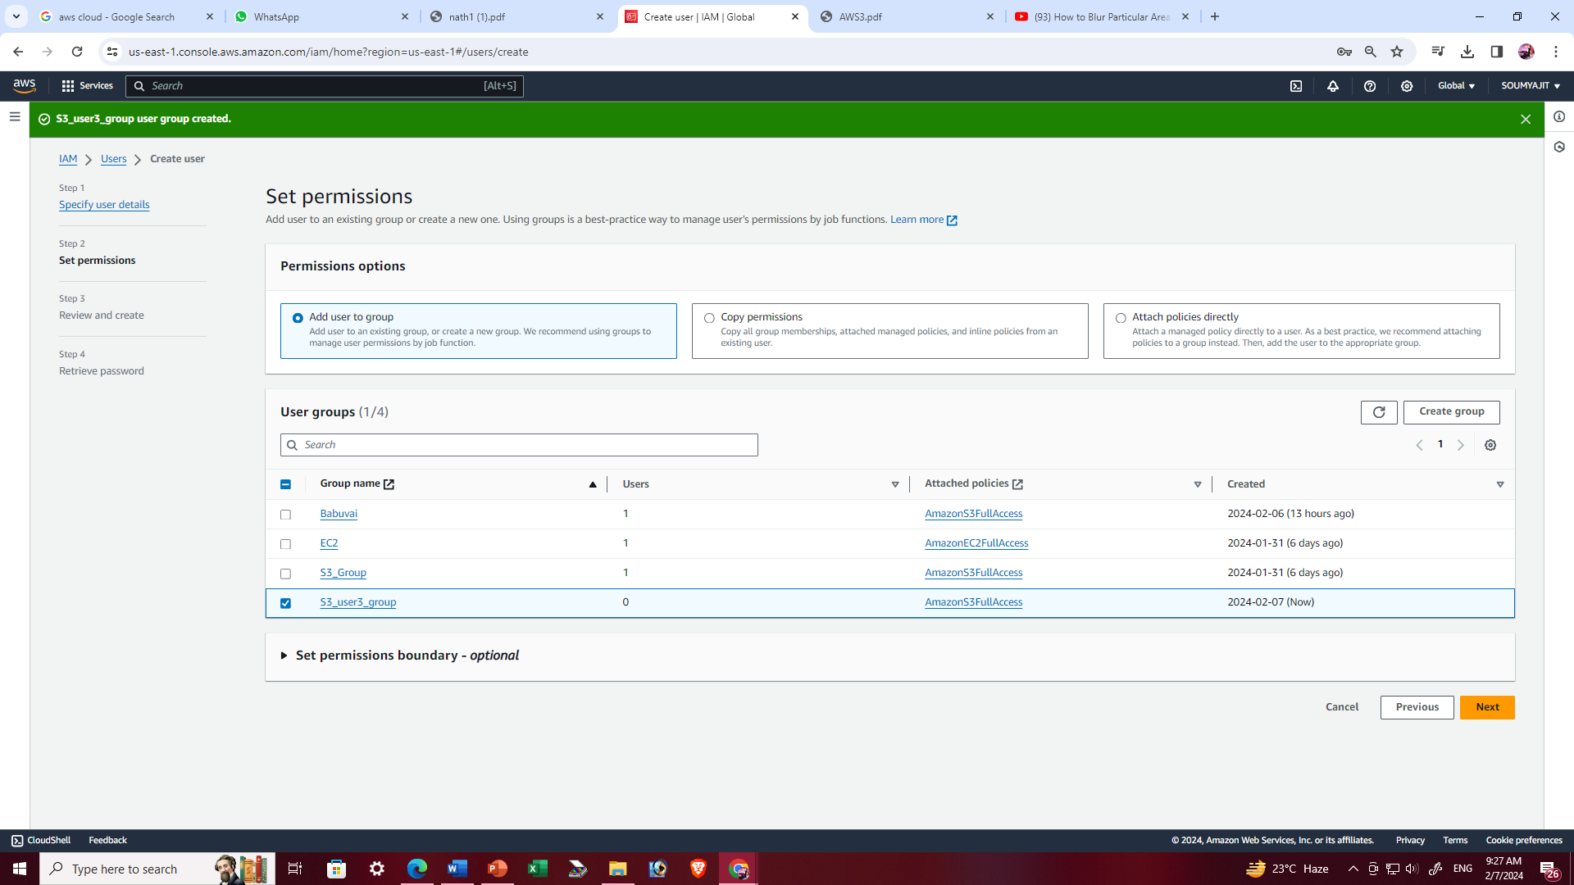

1. Click on ‘Create user’ to create our IAM user.

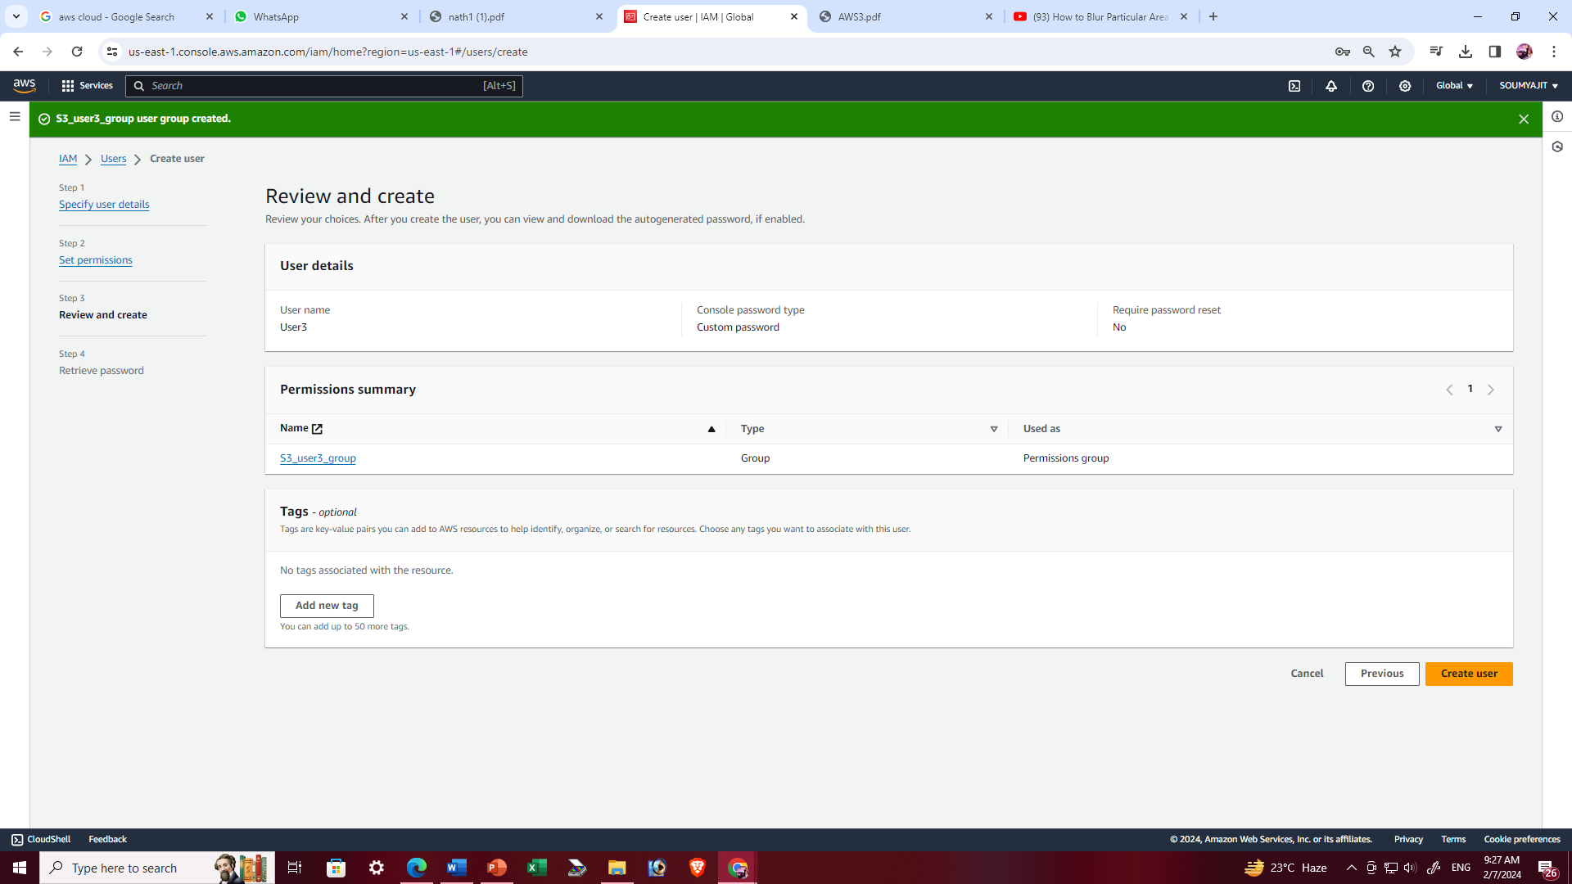

1. IAM user is created successfully.

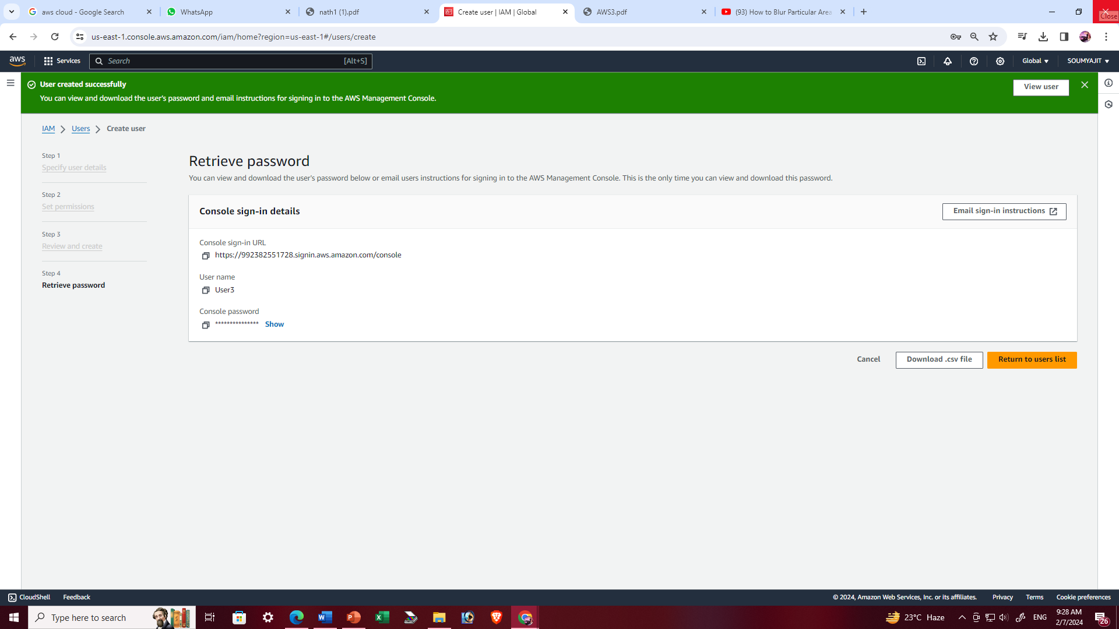

1. Now sign out from the root user and open the aws and sign in in IAM user mode to provide account ID.

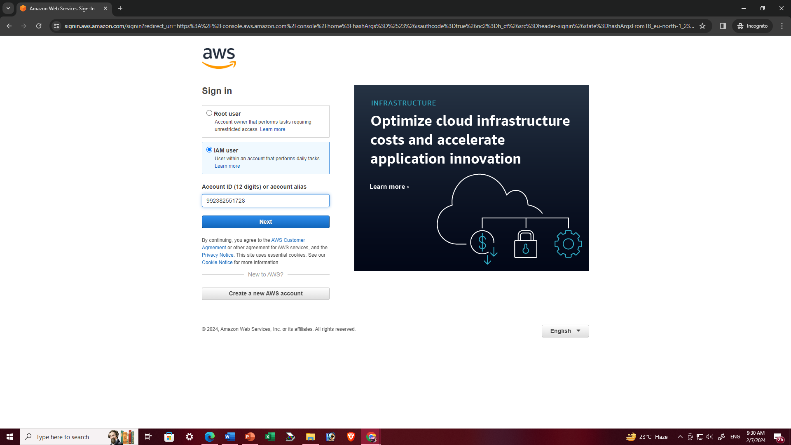

1. Provide the user name and password and sign in.

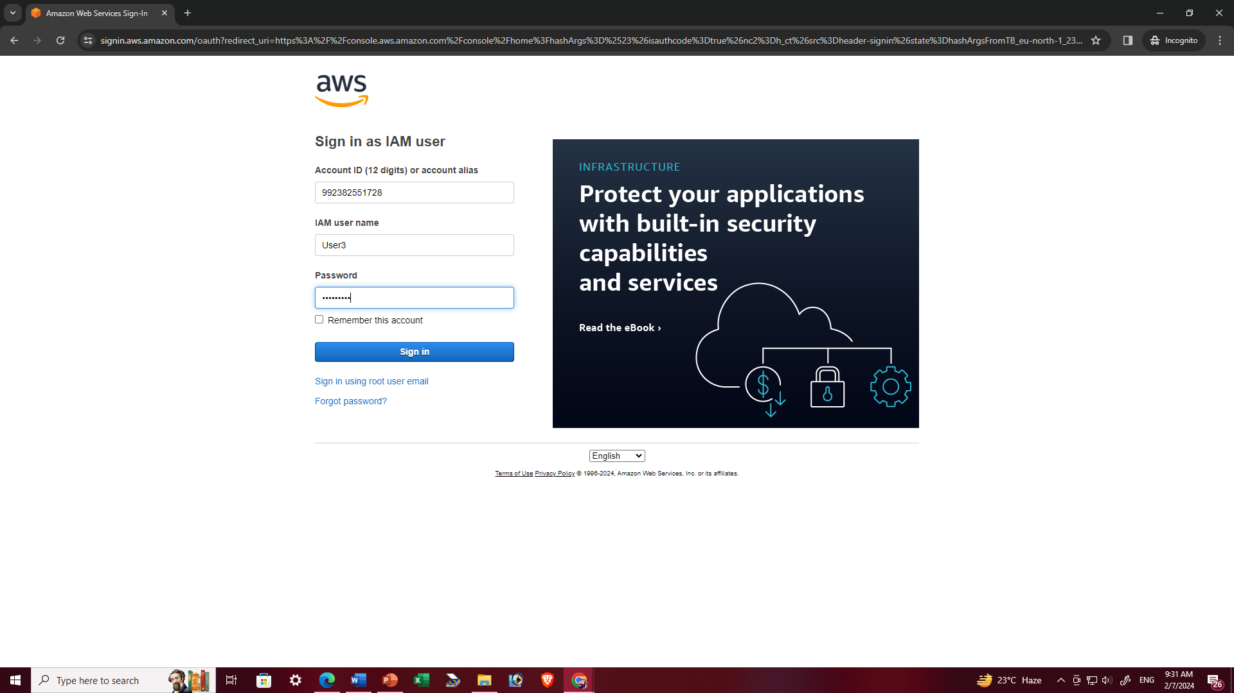

1. Sign in successfully.

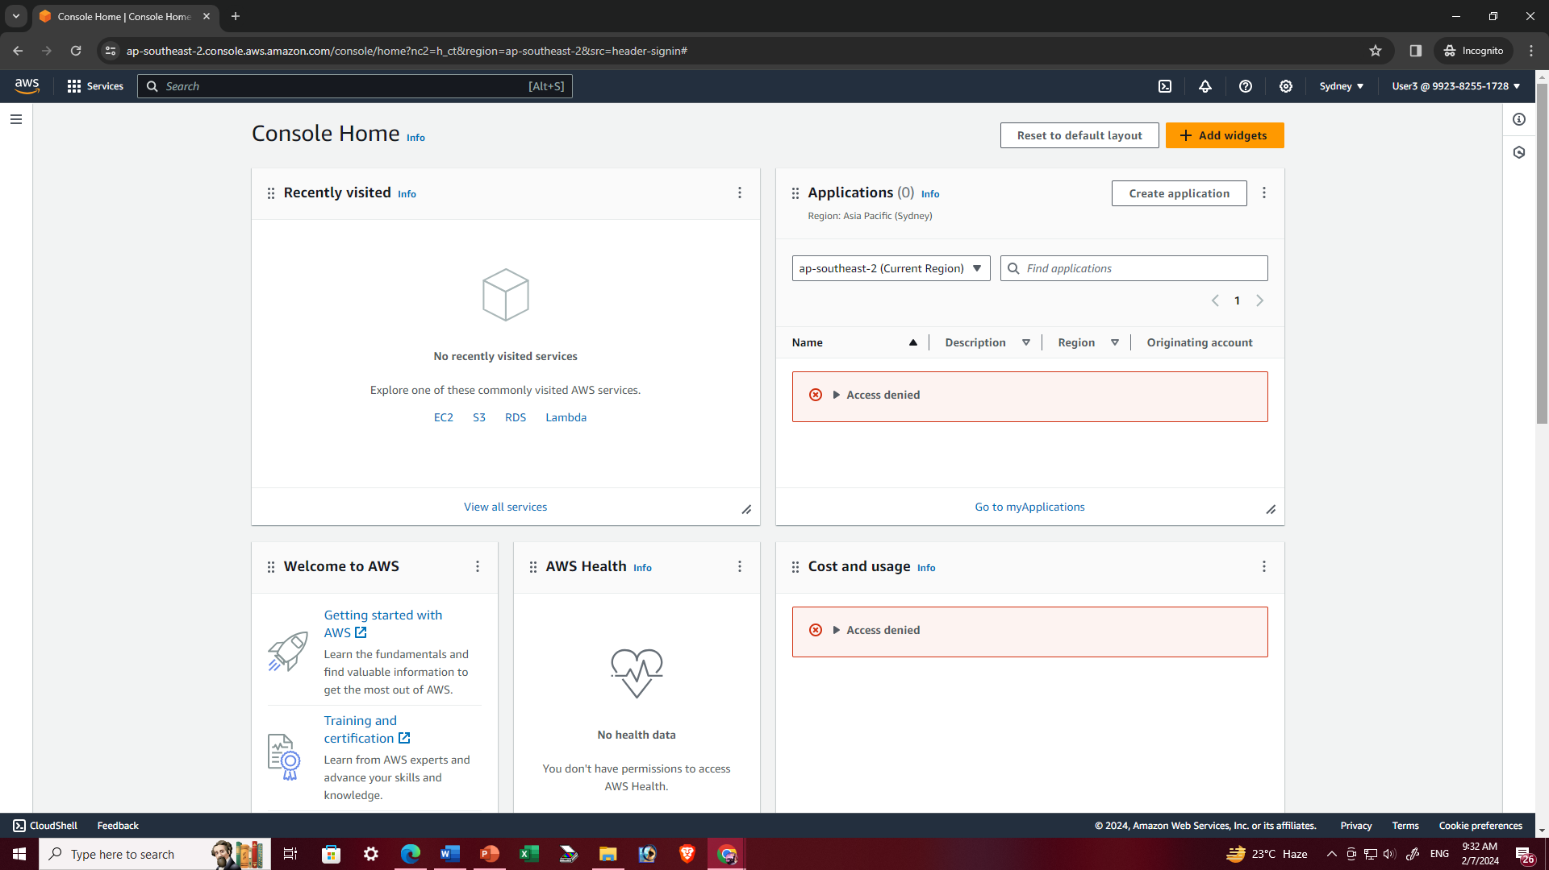

1. Search s3 and enter.

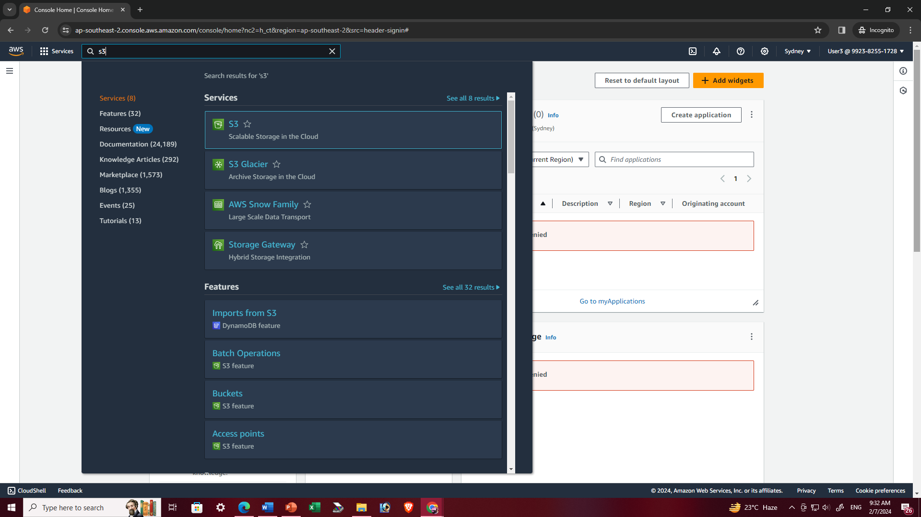

1. It is seen that IAM user is given full access to ‘S3’ successfully and the user can create bucket.

